Ricoh Pro VC20000
Not available in US Market There are 3 versions in the Ricoh Pro VC20000 Series: the 75 metres per minute, 600 x 600 dpi mono Ricoh Pro V20000, the 150mpm, 600 x 600 dpi mono Ricoh Pro™ V20100 and the 75mpm, 600 x 600 dpi CMYK Ricoh Pro™ VC20000.
Product Family: Pro VC
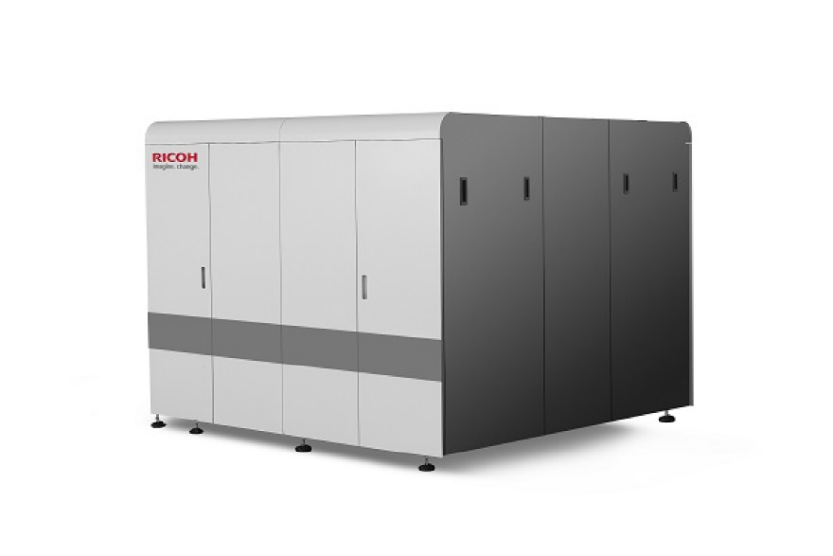

Productivity
Speed Reported
FPM Reported | 225
IPM Reported | 500
Duty Cycle Reported

Digital Front End
Controller Options | TotalFlow R600A
Print Streams | PDF, Postscript, IPDS, JDF

Imaging System
Ink Type | Aqueous Pigment
Ink Description
Ink Options | CMYK
Bonding Agent | not-available
Primer/Precoat | optional
Drying Methods
Head Technology | Piezoelectric Drop-on-Demand
Head Manufacturer | Seiko Epson
Heads Per Engine | Not Reported
Colors | 4
Droplet Size | Not Reported
Gray levels | 4
Resolutions | 600x600

Paper & Media
Paper Feed | Roll
Paper Output | Roll, Sheet, Fold
Minimum Web Width | Pending Verification
Maximum Web Width | Pending Verification
Maximum Print Width Simplex | Pending Verification
Maximum Print Width Duplex | Pending Verification
Minimum Thickness | GSM
Maximum Thickness | GSM
Paper Types
Specialty Media | Not Reported

Market Segments
Manufacturer Segment Notes | Transactional, Direct Mail
Applications Segments | Direct Marketing – Postcards & High Color Direct Advertising  Direct Marketing – Self Mailers  Traditional Transaction Print  Transitional Mail

Configuration
Layout Configuration | I,
Print Engines | 2
Print Sides | Duplex
Power Consumption | Not Reported
Footprint: | Not Reported
Noise: | Not Reported
Weight: | Not Reported
Humidity Range: | Not Reported
Temperature Range: | Not Reported

