Canon Océ JetStream 4300 Wide mono
The Canon Océ JetStream 4300 Wide mono is a continuous feed production inkjet device announced in 2011. The device is targeted at production printing of Books – Monochrome, Direct Marketing – Self Mailers, Traditional Transaction Print. It has a top speed of 4295 and uses aqueous dye ink.
Product Family: JetStream Wide Mono Series
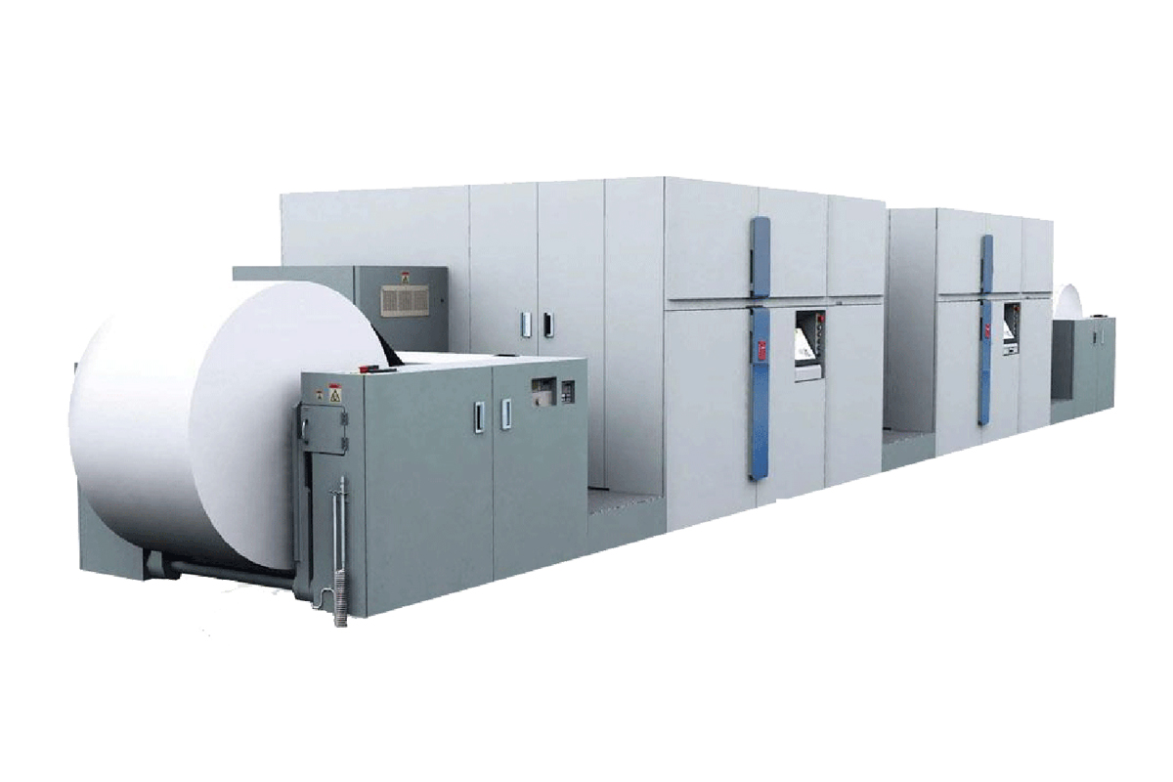

Productivity
Speed Reported | 128,850 sheets/hr
FPM Reported | 656
IPM Reported | 4295
Duty Cycle Reported | up to 139 million letter impressions per month

Digital Front End
Controller Options | SRA MP
Print Streams | IPDS, PCL

Imaging System
Ink Type | Aqueous Dye
Ink Description | Water-based pigment black ink
Ink Options | Monochrome
Bonding Agent | Not Reported
Primer/Precoat | Not Reported
Drying Methods | heated drum
Head Technology | Piezoelectric Drop-on-Demand
Head Manufacturer | Kyocera
Heads Per Engine | 28
Colors | 1
Droplet Size | 7-12 (variable)
Gray levels | 4
Resolutions | 600x600 1200dpi perceived

Paper & Media
Paper Feed | Roll
Paper Output | Roll
Minimum Web Width | 8.5 in / 216 mm
Maximum Web Width | 30 in / 762 mm
Maximum Print Width Simplex | 29.5 in / 749 mm
Maximum Print Width Duplex | 29.5 in / 749 mm
Minimum Thickness | 64 GSM
Maximum Thickness | 157 GSM
Paper Types | Laser, inkjet treated/coated, recycled, book, newspaper
Specialty Media | Pre-printed, pre-punched, pre-perforated

Market Segments
Manufacturer Segment Notes | Transactional, documents, direct mail and short run books
Applications Segments | Books – Monochrome  Direct Marketing – Self Mailers  Traditional Transaction Print

Configuration
Layout Configuration | I
Print Engines | 2
Print Sides | Duplex
Power Consumption | 82 kW
Footprint: | 311 in x 118 in x 77 in / 7900 mm x 2995 mm x 1950 mm
Noise: | < 80 dB
Weight: | 29320 lb / 13300 kg
Humidity Range: | Optimal range 40–60% RH, limited range 30–80% RH
Temperature Range: | Optimal range 68–79°F / 20–26°C, Limited range 61–84°F / 16–28°C

