Canon Océ ColorStream 3900 (Dye Ink Configuration)
Canon stopped marketing the ColorStream 3000 Series in 2018
Product Family: ColorStream 3000 Classic Series
Status: Off market - supported
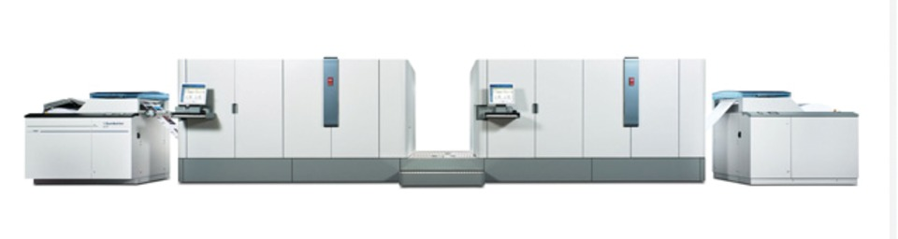
Device Availability Notice
Off market - supported: Devices with this designation are no longer sold by the OEM, however, maintenance plans, support and parts are still available. These devices may also be available as refurbished equipment from the OEM or third parties.

Productivity
Speed Reported | 54,540 sheets/hr
FPM Reported | 417
IPM Reported | 1714
Duty Cycle Reported | 6-28 million letter impressions per month (single) 12-59 million letter impressions per month (twin)

Digital Front End
Controller Options | SRA MP third-generation, high-performance blade processors
Print Streams | IPDS, PDF, PostScript

Imaging System
Ink Type | Aqueous Dye
Ink Description | Water-based dye or pigment, MICR, Security Inks, Océ InkSafe™ technology
Ink Options | CMYK+ MICR and 1 spot or 2 Spot
Bonding Agent | Not Reported
Primer/Precoat | Not Reported
Drying Methods | heated saddles
Head Technology | Piezoelectric Drop-on-Demand
Head Manufacturer | Kyocera
Heads Per Engine | 40
Colors | 6
Droplet Size | 5-12 (variable)
Gray levels | 4
Resolutions | 600x600 1200 dpi perceived

Paper & Media
Paper Feed | Roll
Paper Output | Roll
Minimum Web Width | 6.5 in / 165 mm
Maximum Web Width | 22 in / 540 mm
Maximum Print Width Simplex | 21.25 in / 540 mm
Maximum Print Width Duplex | 21.25 in / 540 mm
Minimum Thickness | 60 GSM
Maximum Thickness | 160 GSM
Paper Types | Preprinted, inkjet, laser and recycled newspaper
Specialty Media | Not Reported

Market Segments
Manufacturer Segment Notes | Transactional documents, direct mail and short run books
Applications Segments | Books – Monochrome  Direct Marketing – Postcards & High Color Direct Advertising  Direct Marketing – Self Mailers  Traditional Transaction Print  Transitional Mail

Configuration
Layout Configuration | I, L, H
Print Engines | 2
Print Sides | Duplex
Power Consumption | 17.5 kW / 35 kW
Footprint: | 138 in x 99 in x 75 in / 3505 mm x 2500 mm x 1905 (single engine)
Noise: | < 75 dB
Weight: | 4509 lb / 2050 kg - (Single engine)
Humidity Range: | Optimal range 40–60% RH, limited range 30–80% RH
Temperature Range: | Optimal range 68–79°F / 20–26°C, Limited range 61–84°F / 16–28°C

